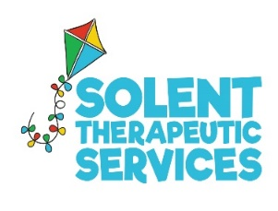 Safeguarding Policy

Solent Therapeutic Services Limited believes that all children should be kept safe from abuse and their development promoted. This policy has been drawn up with guidance which seeks to protect children:
- Children Act 1989
- “Working Together to Safeguard Children” policy 2015
- United Convention of the Rights of the Child 1991
- Data Protection Act 1998
- Sexual Offences Act 2003
- Children Act 2004
- Government guidance on safeguarding children
The welfare and interests of children/young people are paramount regardless of age, gender, beliefs, ethnicity, disability or sexual orientation. Solent Therapeutic Services acknowledges that some children, including disabled children/young people, those from ethnic minority communities or those with communication difficulties can be particularly vulnerable to abuse. Appropriate steps will be taken to ensure their welfare at all times.
As part of this safeguarding policy Solent Therapeutic Services will:
• Promote and prioritise the safety and wellbeing of children/young people
• Ensure that working is in partnership with children/young people, parents and professionals to promote a holistic and joined up approach
• Ensure action is taken in the event of concerns of abuse and support provided to the individual/s who raise or disclose the concern
• Ensure that confidential, detailed and accurate records of all safeguarding concerns are maintained

Monitoring
This policy will be reviewed every year.

